**BUKU PANDUAN**

KERJA PRAKTIK

**FAKULTAS TEKNIK ELEKTRO**



**UNIVERSITAS TELKOM**

**2016**

# PAGE OF APPROVAL

This Field Experience Program (FEP) or *Kerja Praktik* (KP) guide book is written by Writer Team:

1. Dr. Ir. Erna Sri Sugesti, M.Sc.
2. Dr. Memoria Rosi, S.Si, M.Si.
3. Irma Safitri, S.T., M.Sc.
4. Dr. Husneni Mukhtar, S.Si., M.T.
5. Dien Rahmawati, S.Si., M.T.
6. Budhi Irawan, S.Si., M.T.
7. Roswan Latuconsina, ST., M.T.
8. Nur Andini, S.T., M.T.
9. Zulfi, S.T., M.T.

Approved by:

|  |  |
| --- | --- |
| Bandung, April 2019  Head of the Team  **Dr. Ir. Erna Sri Sugesti, M.Sc.**  **Employee ID No. 92660024** | Agreed by,  Dean of School of Electrical Engineering  **Dr. Bambang Setia Nugroho, S.T., M.T.**  **Employee ID No. 99760035** |

# TABLE OF CONTENTS

PAGE OF APPROVAL i

TABLE OF CONTENTS ii

PREFACE iii

I. INTRODUCTION 1

II. COMPETENCES 1

III. OBJECTIVES AND ADVANTAGES 1

IV. THE PRACTICE, SCOPE AND REQUIREMENTS FOR FIELD EXPERIENCE PROGRAM 3

V. GUIDELINES FOR THE PRACTICE OF FIELD EXPERIENCE PROGRAM 4

VI. FEP REPORT CONTENT 5

Chapter 1: INTRODUCTION 5

Chapter 2: FEP INSTITUTION PROFILE 5

Chapter 3: THE PRACTICE OF FIELD EXPERIENCE PROGRAM (FEP) AND CRITICAL DISCUSSION 6

Chapter 4: CONCLUSION AND RECOMMENDATIONS 7

REFERENCES 7

APPENDICES 7

VII. FEP REPORT WRITING FORMAT 8

VIII. FEP SITE 11

IX. THE MECHANISM OF THE PRACTICE OF FIELD EXPERIENCE PROGRAM 12

X. STUDENT TUTORING MECHANISM 14

XI. COMPONENTS OF FIELD EXPERIENCE PROGRAM REPORT ASSESSMENT 16

REFERENCES 18

APPENDICES 19

# PREFACE

All praise and thanks be to The Almighty God, by His approval, this Guide Book of Field Experience Program (FEP) or *Kerja Praktik* (KP) of School of Electrical Engineering (SEE) or *Fakultas Teknik Elektro* (FTE), Telkom University has already been accomplished.

This Guide Book is composed as the guide for the practice of field experience program for SEE students. We realize that this guidebook may still not be flawless. Hence, we expect for some constructive criticism and recommendation for the improvement of this Guide Book of Field Experience Program.

Last, may this Guide Book be an intellectual property usefull for the improvement of the quality of the Field Experience Program as well as for the advancement of SEE of Telkom University

|  |  |
| --- | --- |
|  | Best Regards,  Writer Team |

# INTRODUCTION

Field Experience Program (FEP) or *Kerja Praktik* (KP) as a course is a compulsory course given in an even semester as referred to the Regulation of Telkom University of PU.16/AKD27 /AKD 2018 Article 12 on Rehearsal, Field Experience/Internship, and Industrial Work Experience Program. This program is a real and independent practice taken place in an institution related to School of Electrical Engineering or *Fakultas Teknik Elektro* (FTE). SEE consists of 4 Bachelor or *Sarjana* (S1) Study Programs including Bachelor Program of Telecommunication Engineering, Computer Engineering, Electrical Engineering, and Physics Engineering. By doing a real practice in a workplace, students are expected to understand the interconnectedness of theories, methods, techniques, and the real practice in the workplace. Besides, the experience gained from the program will also give some more knowledge to the students as their ammunition for working after finishing their study.

# COMPETENCES

The competences expected from the students after joining the program are:

1. Students understand work duties and problems found in the field experience program site related to each study program in SEE.
2. Students understand methods in solving problems found in the program site related to each study program.
3. Students are able to take some lessons from the problems as well as give some solutions by comparing and relating them to the theories and concepts studied in university and compose them into a report.

# OBJECTIVES AND ADVANTAGES

The objectives of this program are:

1. Students have some practical experience which is in line with their study program.
2. Students have a real picture on work environment.
3. It is expected that the program provides some benefit and new knowledge for the students or the FEP site.
4. Students spend their semester holiday with something useful that supports their skills.

The advantages of this program are:

1. Knowing or understanding problems and what is required by any work duties in the FEP site.
2. Adapting, and preparing themselves in facing work environment after finishing their study.
3. Knowing or directly seeing the use or the importance of applied technology in the FEP site.
4. Presenting what have been obtained from FEP in a Report.
5. It is expected that they can use the data obtained from FEP site to be developed into a Final Paper.

# THE PRACTICE, SCOPE AND REQUIREMENTS FOR FIELD EXPERIENCE PROGRAM

Field experience program as a course with academic load of 2 units of credit is conducted in the academic year-end holiday where the earliest is after the end of the 6th semester, for 6 – 8 weeks minimum outside the course schedule within a full work hour (8 hours a day) within a full workday (5 days per week). However, the work placement is in accordance with the proposal from the University addressed to the Dean in accordance with the application from the student approved by the Advisor Lecturer. The enrollment term for FEP is at least 4 (four) months before the practice by filling out the application form for FEP approved by Advisor Lecturer.

The scope of Field Experience Program is:

1. The practice for knowledge and skills gained from college aimed at giving some contribution in solving some problems in different companies/institutions, in the workplace related to the clusters of science offered at the faculty.
2. The work scope for this program is not only limited to studies, but should also cover some real/concrete products, like: analysis and result or recommendations for solving a problem, a simple product, design, training module, work procedure module, etc.

The requirements for the program, however, include:

1. Being actively registered as a student in the on going semester;
2. Having completed Rehearsal course;
3. Having completed 80 Units of Credit with GPA > 2.00 minimum and or having completed the sophomore year;
4. The program is taken in the on going semester.

# GUIDELINES FOR THE PRACTICE OF FIELD EXPERIENCE PROGRAM

To support the field experience program in an Institution/Company, students are required to keep in mind the following guidelines:

1. Abiding by all regulations and breaking no rules regulated by the institution/company, including keeping any confidential information of the institution/company;
2. Completing all the tasks given by the institution/company as well as they can under the time given;
3. Performing a good attitude, personality, and manner;
4. Maintaining honesty and discipline;
5. Growing abilities in managing the recommendations from the field advisor as well as their initiatition and independency in accomplishing tasks;
6. Trying to develop their capability and professionality in working;
7. Preserving alma mater’s name;
8. Using a clean and neat suit, wearing shirt and covered shoes;
9. Using FEP ID card (if any);
10. Being present as scheduled, as required by the FEP site;
11. No smoking in no smoking areas, no drinking alcohol, taking no weapon, gun and narcotics to the FEP site;
12. Maintaining the cleanliness, beauty and neatness of the site;
13. Writing and presenting the FEP Report to the academic advisor and the examiner. The report should be submitted to the advisor lecturer, as the academic advisor, and the presentation before the FEP examiner should not be more than 1 month after the end of the FEP.

# FEP REPORT CONTENT

The title of FEP report should not be too general, representing the practice of the Field Experience Program. The main contents of the report are 4 chapters (maximum) comprised by Introduction, The Institution Profile, The Practice and Critical Discussion as well as Conclusion and Recommendations.

## Chapter 1: INTRODUCTION

This chapter consists of:

* 1. The background of the FEP assignment describing the reasons why the student decided to do the FEP in the Institution he/she chose;
  2. The scope of the assignment describing the time, place and practice of FEP;
  3. The target of problem solving found in the program describing the targets expected from the assignment;
  4. The practical/problem solving method describing the ways or methods used in the site and the report writing method;
  5. Plan and work scheduling, consisting the schedule and steps taken to accomplish the task given in the assignment;
  6. Report structure summary, including a short description of each chapter reported.

## Chapter 2: FEP INSTITUTION PROFILE

This chapter consists of Company/Institution Profile, Organizational Structure, and location/program site.

1. Institution/Company profile includes a short description of the FEP site;
2. Organizational Structure, describing managerial hierarchy along with the work flow chart in the Company/Insitution;
3. Location/program site, describing the assignment site.

Insert the picture of location site, building and the room of the site, as can be seen in the sample of Figure 2.1. Figure of 2 means that the Figure is in Chapter II while figure of 1 means that it is the first figure in the Chapter. Insert the source if the figure is taken from a certain site.

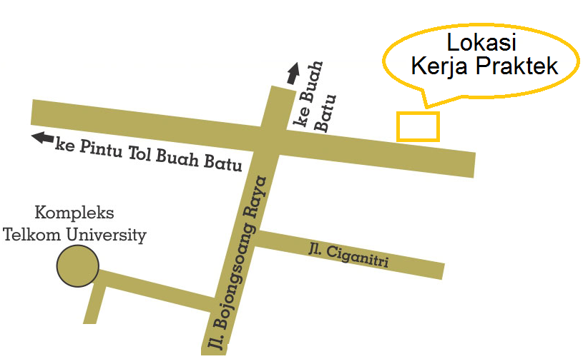

Figure 2.1. Map of Field Experience Program Site[4].

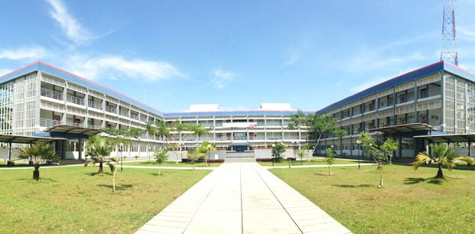

Figure 2.2 Building of Field Experience Program site[5].

Figure 2.2. is the sample for the building of the site where FEP is taken place. The practice of FEP consists of a short description on the project/the work practice the participant carried out within FEP.

## Chapter 3: THE PRACTICE OF FIELD EXPERIENCE PROGRAM (FEP) AND CRITICAL DISCUSSION

This chapter consists of:

1. Description on the involvement of students on what, when how long, with whom they do the program, the results, picture, figure, supporting material related to FEP. In this case, it can involve some related theories/concepts/methods/technique/procedure, supported by data and notes from logbook. Insert some pictures of the activities as documentation, as in Figure 3.1 depicting an activity carried out by the students doing FEP.

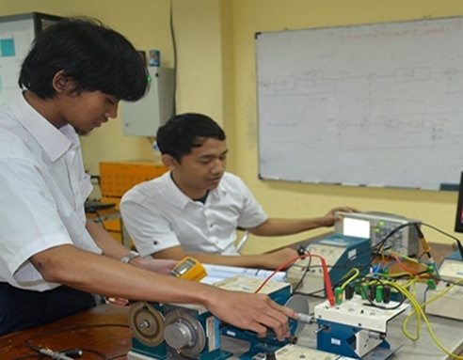

Figure 3.1 Sample of an activity in Field Experience Program[4].

1. Critical analysis on:
   1. precious lessons taken from the field experience program;
   2. analysis on the problem solving proposed;
   3. comparison of theories which have been studied and the implementation;
   4. good/bad experiences.

The structure of Chapter 3 is similar to the report of practicum journal.

## Chapter 4: CONCLUSION AND RECOMMENDATIONS

This chapter consists of either conclusion on the practice of FEP, written comprehensively, clearly and briefly, or recommendations including:

1. recommendations for the Company/Institution or project/activities based on what have been practiced in FEP; and
2. recommendations on the revision of the content of the report or to enrich knowledge particularly knowledge related to the study programs in School of Electrical Engineering.

## REFERENCES

## APPENDICES

1. Copy of the Application to the company/institution;
2. Copy of the reply of the Application from the company/institution;
3. Assesment form from the Field Advisior from the company/institution;
4. Logbook.

# FEP REPORT WRITING FORMAT

This chapter describes the paper format and the writing guidelines for FEP report:

1. Material and Size
2. Report is written on A4 HVS paper of 80 gram.
3. The Report is printed and covered with white laminated soft cover as many as:
   * one copy for the student’s archive;
   * one copy for the company/institution (if asked);
   * one copy for the Academic Advisor (if asked);
   * upload the soft copy to the repositoty of University and or to the students’ blog.
4. For similarity checking purpose, upload Chapter III and IV in word format to a specified address announced by LAA.
5. Submit the revised version of the report softfile in CD to LAA.
6. Typewriting
7. Font
8. Report is typed in **Times New Roman font size of 12**. Italics and square are not allowed except for foreign language.
9. Spacing is made into 1.5 line spacing except for direct quotation, title of table and figure as well as reference that use single line spacing.
10. The margin is 3 cm at the top, right, and bottom side and 4 cm at the left side of the paper.
11. Every chapter should be orderly numbered with Romance numerals and the title of a Chapter is typed at the center side symmetrically in capital letter without any line and full stop.
12. Chapters are divided into several sub chapters which are orderly numbered with Arabic numerals. The numbering for sub chapters uses two digits of figures: the first figure refers to the number of the chapter, while the next figure refers to the number of the sub chapter. Between the two figures, a full stop is inserted. Between the number of sub chapter and the first word of the sub chapter, 1 single space is inserted. The first letter of the words in the title of sub chapters is in capital letter, except for conjunction.
13. Numbering
14. Page

* The front parts of the report from the title until the list of appendices are page numbered with small Roman numerals.
* The page numbering for the first until the last page of the report uses Arabic numerals, for example: 1, 2, 3, etc.
* The page number is arranged on the upper right hand portion of the paper, except for the new chapter page where the title of the chapter is written in the upper side of the paper, the page number is then arranged in the center of the bottom of the page.

1. Table

* The title of a table is written above the table, in the center. The first letter of a title is in capital letter and the title sentence is ended by a full stop.
* The table number is written in Arabic numerals.
* The table number followed by a title is arranged symmetrically above the table.
* Every table should not be splitted, except if it is too long and cannot be put in a single page where on the next page consisting of the rest of the table, the table number is inserted and the rest word is printed in bold and written in brackets. If in portrait position the table cannot fit the page, it is then set into landscape.

Table 3.1 Sample of table of analysis of fractal dimension[7].



1. Figure

* The first letter of the title of a figure is in capital letter with font of Times New Roman, size 11.
* The number of a figure is written in Arabic numerals.
* The number of a figure followed by a title and its source is placed symmetrically below the figure.
* The sample of figure can be seen in Figure 3.1 [6].

1. References

* References are listed in alphabetical order and numbered started from 1.
* The Referencing is in accordance with IEEE comply with what has been installed in MS Word.
* Referencing :

Journal : The writer, “the article title”, journal name (italicized), volume, number, page, month year of issued

E.g.:

J. S. Turner, “New directions in communications,” *IEEE J. Sel. Areas Commun*., vol. 13, no. 1, pp. 11-23, Jan. 1995.

Book : The author, “book title”, edition (if any), volume (if any), city of issuance, country: publisher, year of publication, page.

E.g.:

G. O. Young, “Synthetic structure of industrial plastics,” in *Plastics,* 2nd ed., vol. 3, J. Peters, Ed. New York, NY, USA: McGraw-Hill, 1964, pp. 15–64.

Website :The reference at least covers the information of the writer’s/editor’s name, the name and address of the website, the article title, the date of the article, and the date of download.

E.g.:

L. Leicht, “Oxford Scholar Explores a Third Layer of Meaning in Narnia.” News-leader.com. 30 March 2012. 15 April 2012 <<http://www.newsleader.com/article/20120331/LIFE07/303310032/narnia-religion-faith&gt>>

Quotation taken from a source should be informed clearly in the text, i.e. by inserting the reference number of the source as listed in the Reference list. For example ….. formal method [5]. Figure of 5 here means that it is in the 5th order in the Reference.

# FEP SITE

The program can be conducted in following institutions:

1. Either state or private company;
2. Either national or foreign company/institution;
3. Operator, manufacture industry, regulator, including:

|  |  |
| --- | --- |
| * + Telecommunication service, | * + Governmental institution, |
| * + Communication device industry, | * + International organization and foreign representative office, |
| * + Telecommunication contractor, | * + Nongovernmental organization |
| * + Telecommunication consultant, | * + Space agency |
| * + Postal and shipping service operator, | * + Financial and banking industry |
| * + Military and police institution | * + Supermarket chain |
| * + Energy and electrical management insititution | * + Food industry |
| * + Research institution | * + Air transportation operator, |
| * + Small and middle enterprise development | * + Airport management |
| * + Information service provider | * + Sea transportation operator, |
| * + TV and Radio broadcasting agency | * + Tollway management, |
| * + News office | * + Farming and forestry industry, |
| * + Pers publishing company | * + Hospital |
| * + Autuomotive and manufacturing company, | * + Chemical and Pharmaceutical industry |
| * + Oil and mining company , | * + Governmental institution in transportation, information and telecommunication |
| * + tourism and hospitality link, |

1. For international class, the company addressed is multinational company. Multinational company is company where the business is conducted in different contries or nations.

# THE MECHANISM OF THE PRACTICE OF FIELD EXPERIENCE PROGRAM

The program is conducted under the following mechanism, i.e. as can be seen in Figure 9.1 in detail.

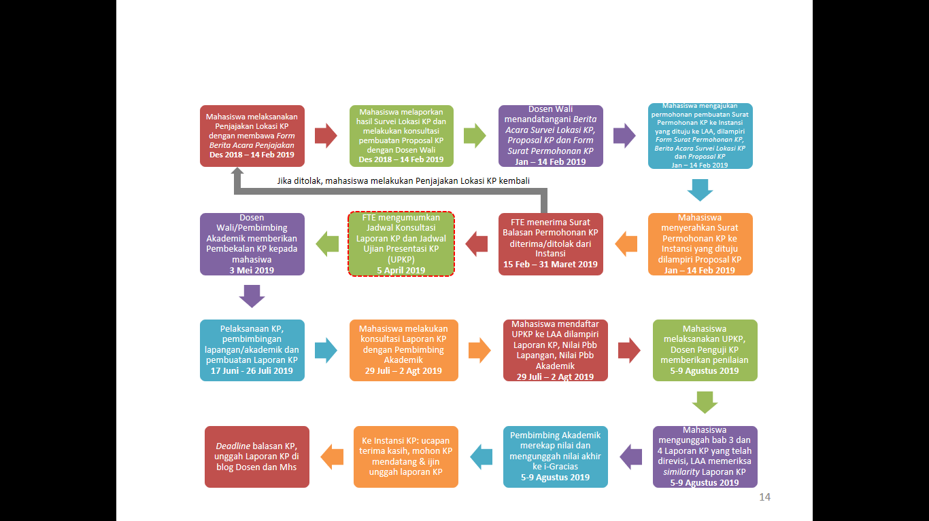

Figure 9.1 Flowchart of the Mechanism of Field Experience Program.

**1. Survey/Negotiation for FEP Site Mechanism**

* 1. Student comes to LAA and hands KSM (Student Study Card) in as the proof that he/she is an actively registered student and takes FEP course in the ongoing semester where KHS (Student Report Card) is the proof that he/she has passed 80 units of credit minimum and has passed Rehearsal course;
  2. Student fills out FEP data in LAA computer;
  3. LAA prints Survey/Negotiation Cover Letter for FEP site;
  4. Student comes to LAA and takes the Formal Report Form of Survey/Negotiation for Field Experience Program (FEP) site;
  5. Student does the Survey/Negotiaiton for FEP site to the company, bearing the Formal Report form;
  6. Student and the representative of the company sign the Formal Report form.

**2. FEP Proposal Making Mechanism**

1. Making FEP proposal draft based on the Survey/Negotiation that has been conducted;
2. Student does the consultation/tutoring for the FEP Proposal with his/her Advisor Lecturer/Academic Advisor;
3. The Advisor Lecturer/Academic Advisor signs the FEP Proposal and the Formal Report form;
4. Student records the consultation/tutoring for the FEP Proposal activity in Logbook, The Advisor Lecturer/Academic Advisor signs the Logbook.

**3. Mechanism in Making Application Letter for FEP to Company**

* 1. Student comes to LAA and submits FEP Application Letter signed by his/her Advisor Lecturer/Academic Advisor enclosed with FEP Proposal and Formal Report of Survey/Negotiation of FEP Site signed by the Advisor Lecturer/Academic Advisor;
  2. LAA prints the Application Letter for FEP to a Company;
  3. Student comes to LAA and takes the Application Letter for FEP to the Company;
  4. Student sends/hands in the Application Letter for FEP to the Company;
  5. LAA sends the information whether the Application is accepted/rejected by the Company to the student, and or the student sends the accepted/rejected letter to LAA.
  6. If the application is rejected by the Company, the student starts over the mechanism, conducts **1** until **3**.

# STUDENT TUTORING MECHANISM

Within Field Experience Program (FEP), students have two advisors including field advisor and academic advisor (advisor lecturer). Field advisor is the one appointed by the head of the institution where the students do the FEP or the direct supervisor of the students at the FEP site. The function of the field advisor is to give some guidance if needed, examine the students’ performance in doing the FEP and sign the students’ logbook.

Academic advisor is the students’ advisor lecturer. In this case, his/her task is to

* Give some advice on the feasibility of the work the students will do for their FEP;
* Give some guidance in writing the FEP report;
* Examine the FEP tutoring;
* Recap the score of FEP from the field advisor and Examiner Lecturer;
* Upload the score to i-Gracias.

**10.1 Field Tutoring Mechanism**

The followings are some guidelines for having some tutoring sessions with Field Advisor:

1. Student brings the FEP document to be known or sent to the company/institution of FEP.
2. Student gets a field advisor.
3. Student sends the document related to the practice of FEP to the field advisor.
4. Student asks for guidance or the procedure to do FEP to the field advisor, or shows the work plan in the FEP proposal.
5. Student does the work in accordance with the field advisor’s guidance.
6. Student consistently fills out the DAILY Logbook and periodically submits it to the field advisor to be checked, approved and signed.
7. Student does the problem and solution analysis.
8. Student writes the FEP report in his/her leisure time within the program.
9. The report draft is submitted to the field advisor and discussed in the tutoring sessions.
10. Student revises the report draft, presents (if asked) and asks for the approval of the report.
11. The report is bundled and submitted to the field advisor.

**10.2. Consultation Mechanism**

Each student is required to have some consultation at least 3 times with the academic advisor. The consultation materials are :

* 1. Discussion on FEP Report draft.
  2. Checking on the first revision of the report.
  3. Checking on the final revision and approval of the report as well as uploading the report (chapter 3 and 4) to have some similarity check.

The consultation is carried out in accordace with the planned schedule or adjusted to the real condition considering the work eficiency of each advisor.

**10.3 Assessment Criteria for FEP Academic Advisor**

After students accomplish the program as well as the report, the program will be assessed under the following criteria:

1. Frequency of Tutoring / Consultation.
2. The Structure of the FEP report, as referred to the FEP guide book.
3. The conformity of the activities carried out during the program with the Specialization in their Study Program/FEP proposal.
4. The conformity of Logbook with the FEP work plan stated in proposal.

**10.4 Assessment Criteria for PTFEP Examiner**

Besides the score from the Field Advisor and Academic Advisor, students are required to present what they have obtained from FEP with the following criteria:

1. Understanding towards the Work Problems.
2. The content of the Field Experience Program report.
3. Presentation technique.

# COMPONENTS OF FIELD EXPERIENCE PROGRAM REPORT ASSESSMENT

There are 7 components for Field Experience Program (FEP) assessment as referred to the report writing format explained above. Further detail on the weighting can be seen in Table 11.1, Figure of 11.1 means that the table is the first table in chapter 11.

Table 11.1 Weighing for the scoring of FEP Report

|  |  |  |  |
| --- | --- | --- | --- |
| No | Components assessed | Maximum criteria | Weight |
| 1 | Title, Table of Content, List of Tables and List of Figures | Identified and conform to the required format | 5 |
| 2 | Chapter I Introduction (Background, Objectives, Scope, the Practice, Report Structure) | Identified, correct and conform to the components examined, | 10 |
| 3 | Institution Profile | Identified and feasible to be FEP site | 10 |
| 4 | FEP practice | Identified, correct, presents some critical study from the student, and can be related to the field of knowledge/course in the Study Program | 40 |
| 5 | Conclusion and Recommendations | Identified, related to what has been practiced | 15 |
| 6 | References | Identified, conform to the required format | 5 |
| 7 | Appendices | Identified, conform to the guidelines | 15 |
| Total score | | | 100 |

**The Assessment for FEP includes:**

1. Field Advisor with 50% of weight covers: the attendance, adaptation, contribution or ability in accomplishing tasks.
2. Academic Advisor with 10% of weight covers: the attendance in tutoring sessions in logbook, the structure and content of report.
3. Examiner with 20% of weight covers the mastery of the material of FEP and the presentation technique using Power Point
4. Similarity with 20% of weight while the scoring rules are as follows:

0 - 30% : 100 points

30,01% - 35% : 75 points

35,01% - 40% : 50 points

>40% : 5 points

5. All related to the scoring either what has been assessed in the field, FEP report or the test will be combined in an assessment sheet.

# REFERENCES

1. Universitas Telkom, Pedoman Akademik Universitas Telkom (Telkom University Academic Guidelines). Bandung,

2015.

1. FT UGM, *Buku Panduan KP Prodi Perencanaan Wilayah & Kota* (FEP Guide Book of the Urban & Regional Planning Study Program). UGM, 2013.
2. Politeknik Negeri Bandung, *Panduan TA dan Praktik Kerja Lapangan Politeknik Negeri Bandung* (Guidelines for Final Paper and Field Experience Program of Politeknik Negeri Bandung ). Bandung, 2014.
3. Urbankost, Gallery. 27 April 2016<http://www.urbankost.com/UrbanKost.
4. Universitas Telkom, *Borang* *Akreditasi* *FTE* (Accreditation Form of School of Electrical Engineering). Bandung, 2016.
5. Resi Rusmawarningsih, Nurhasanah, and Joko Sampurno, *“Karakterisasi Citra CT Scan Otak Menggunakan Analisis Fraktal Berbasis Transformasi Fourier”*, (“Image Characterization of Brain CT Scan Using Fourier Transformation Based Fractal Analysis”) *Jurnal Fisika*, vol. 1, no. 8, page. 1-8, April 2018.

# APPENDICES

1. Formal Report Form of Survey/Negotiation for Field Experience Program (FEP) site
2. Field Experience Program (FEP) Work Plan Proposal
3. Sample of Field Experience Program (FEP) Proposal
4. LOGBOOK 1: Discussion record with academic advisor
5. LOGBOOK 2: Student activity record of Field Experience Program (FEP)
6. Title Page of Field Experience Program (FEP) Report Format
7. Page of Approval of Field Experience Program (FEP) Report Format
8. Field Experiene Program Report Structure
9. Field Experience Program Application Form
10. Assessment Form for Academic Advisor of Field Experience Program (FEP)
11. Assessment Form for Field Advisor of Field Experience Program (FEP)
12. Assessment Form for Presentation Examiner of Presentation Test of Field Experience Program (PTFEP)
13. Formal Report of Field Experience Program (FEP) Briefing

APPENDIX I

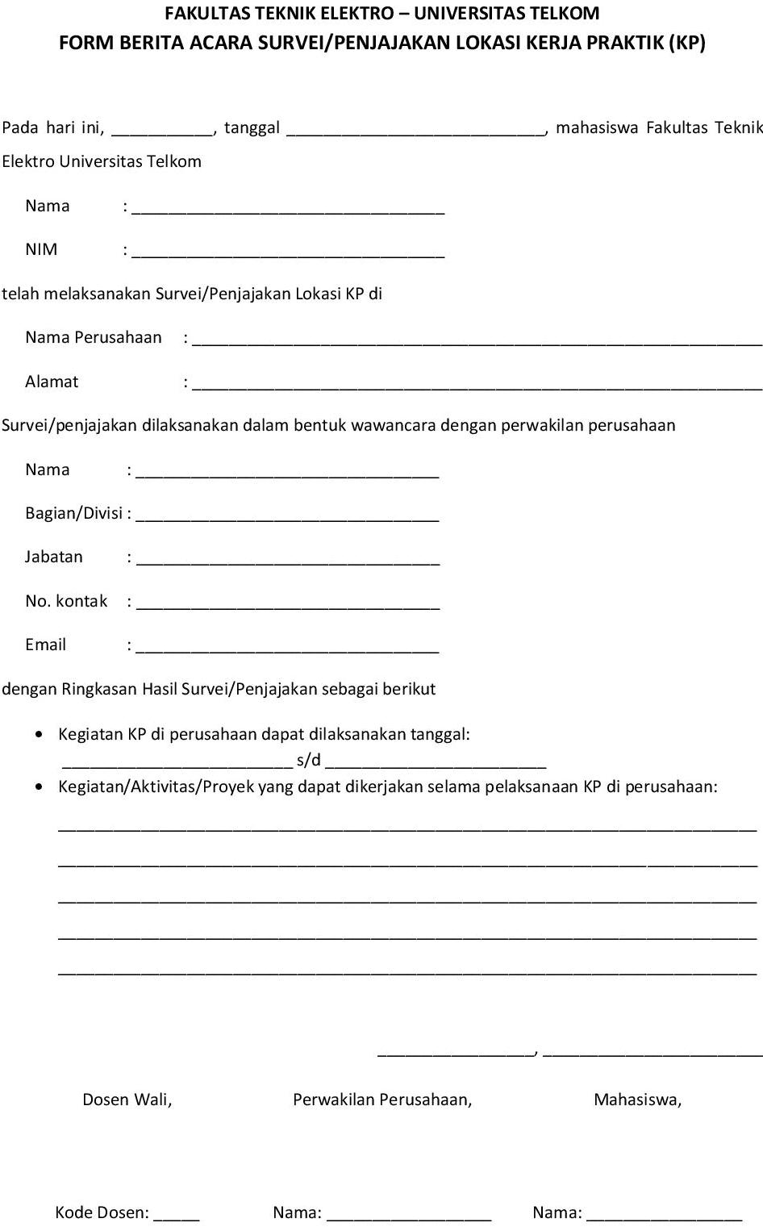

APPENDIX II

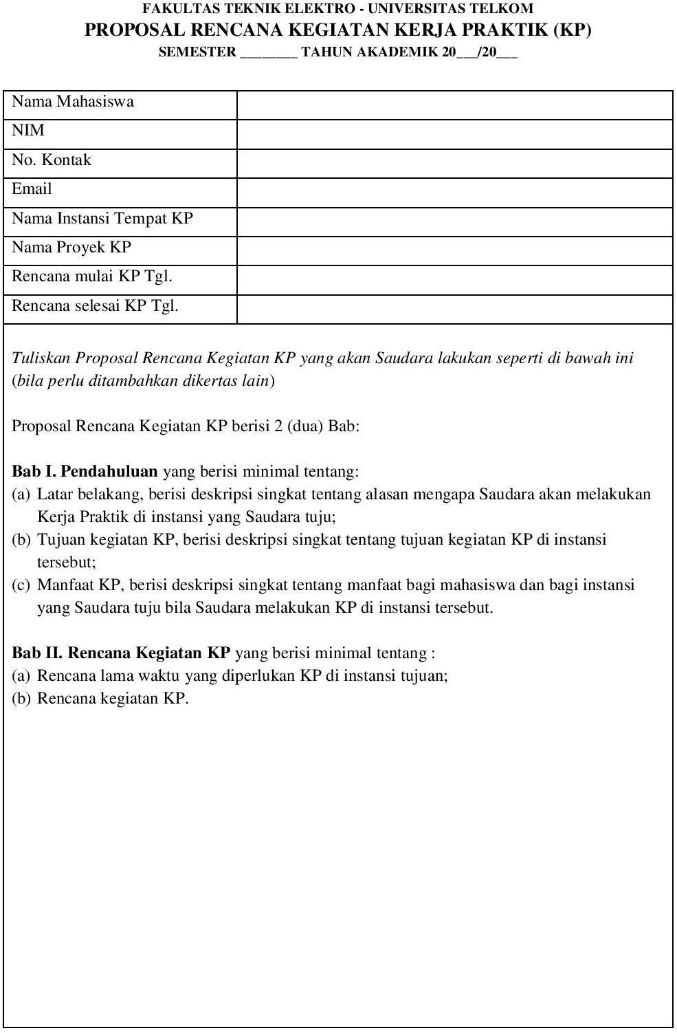

APPENDIX III

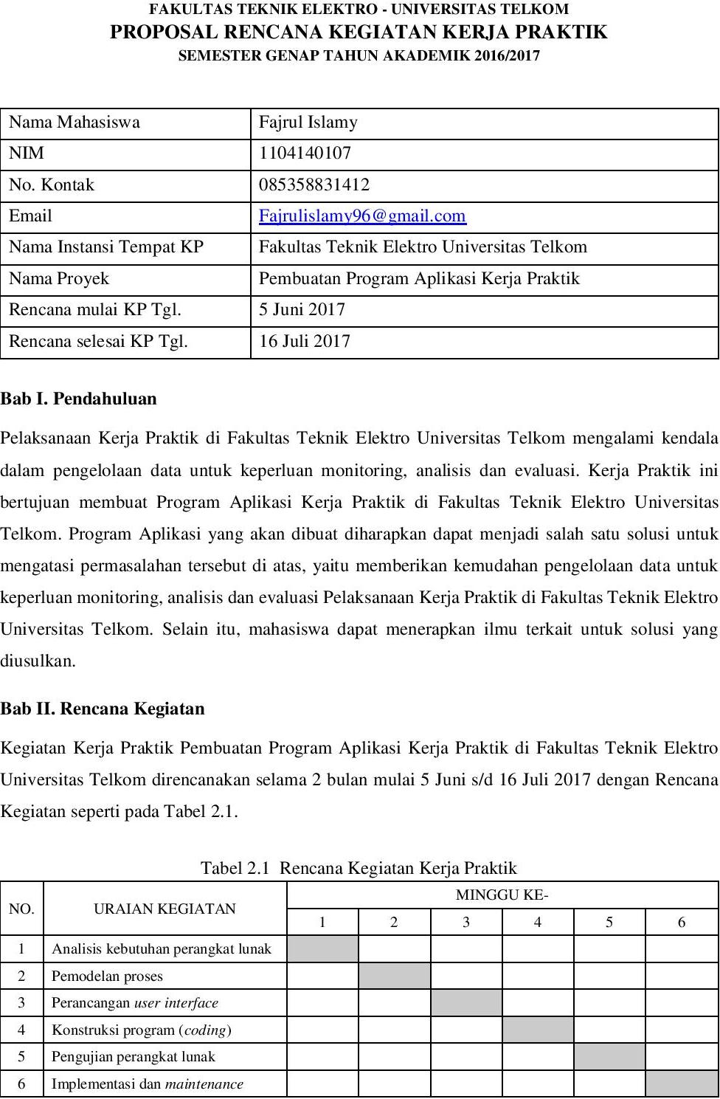

Mengetahui,

TTD

Kode Dosen

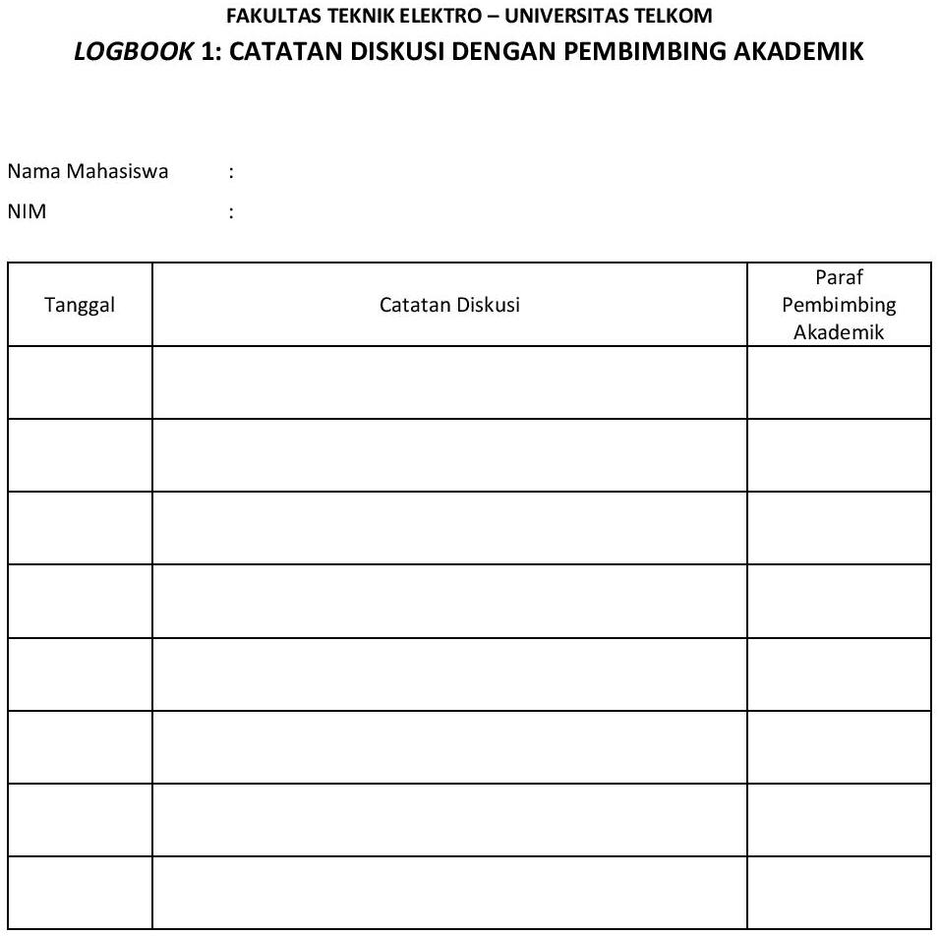APPENDIX IV

APPENDIX V

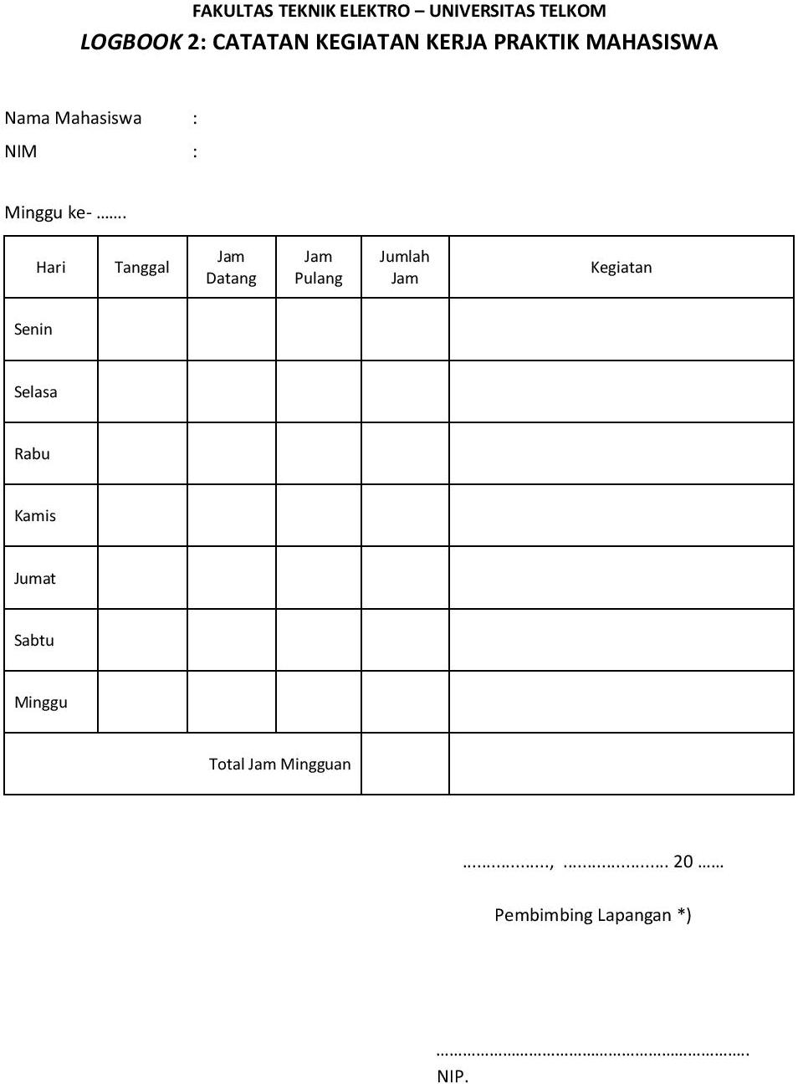

APPENDIX VI



**Periode 17 Juni – 26 Juli 2019**

**2019**

APPENDIX VII



**Periode 17 Juni – 26 Juli 2019**

APPENDIX VIII

Field Experience Program Report Structure



iv. *Logbook*

BAB IV

Kesimpulan dan Saran

APPENDIX IX

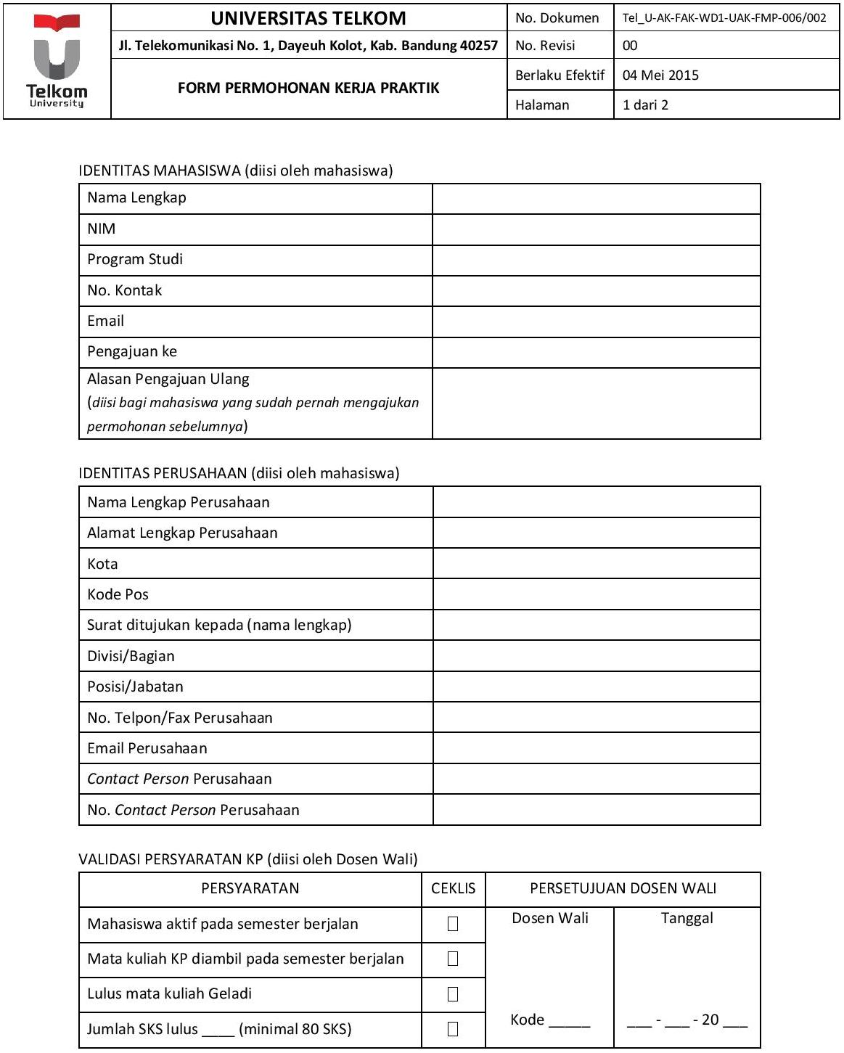

25 April 2018

APPENDIX X

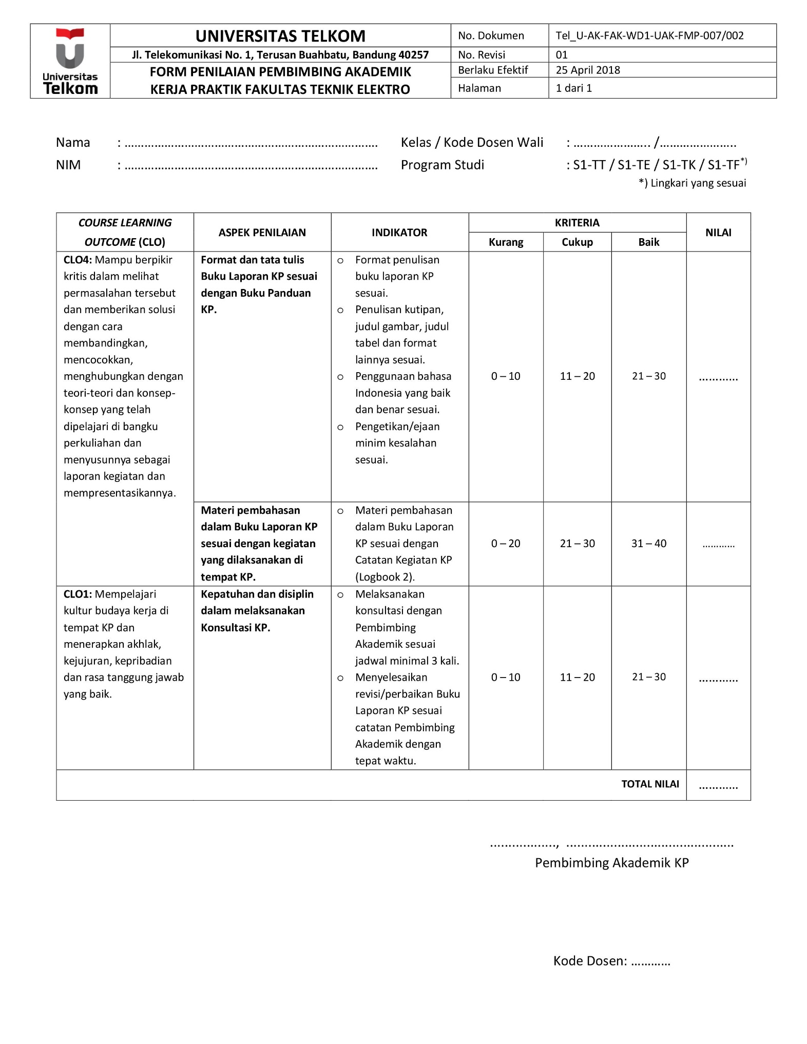

APPENDIX XI

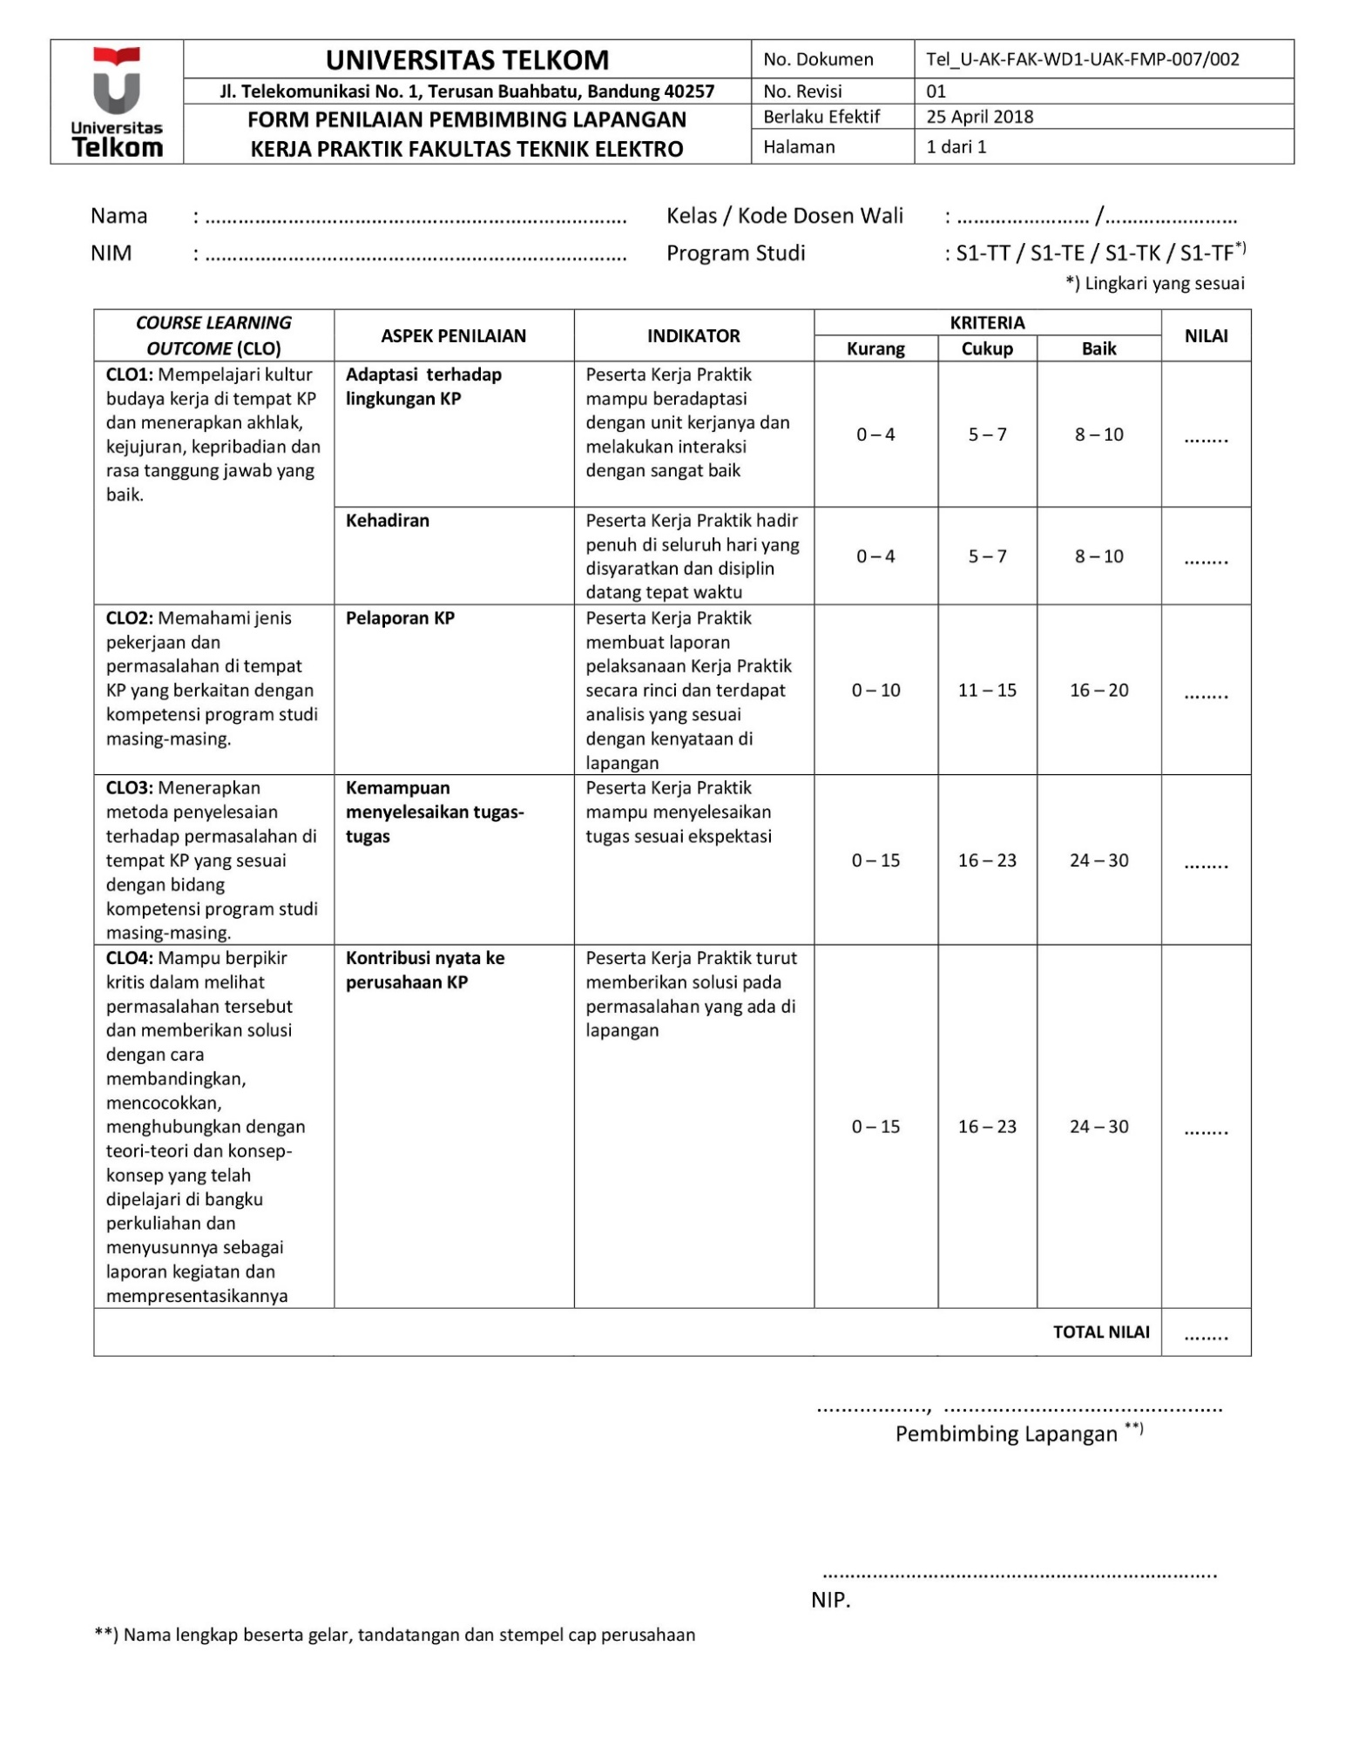

APPENDIX XII

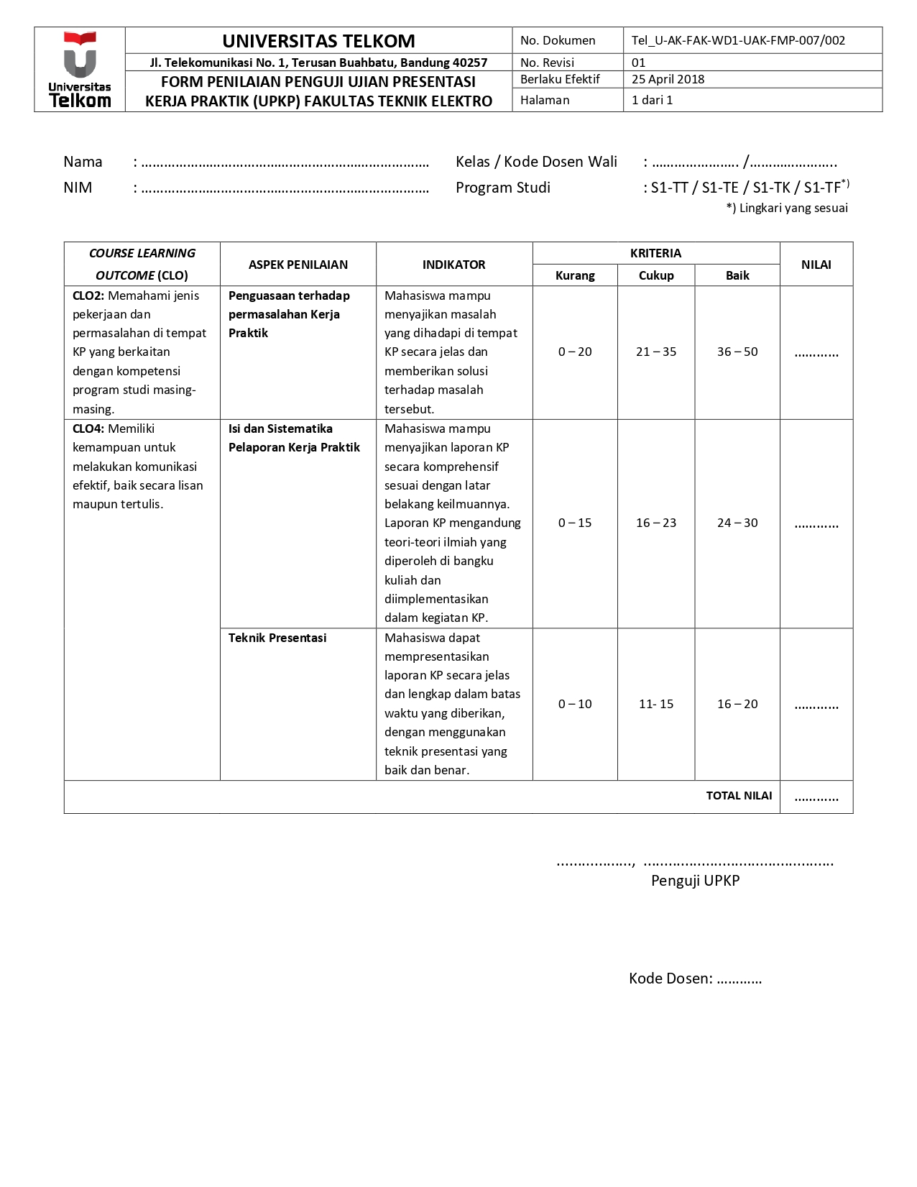

APPENDIX XIII

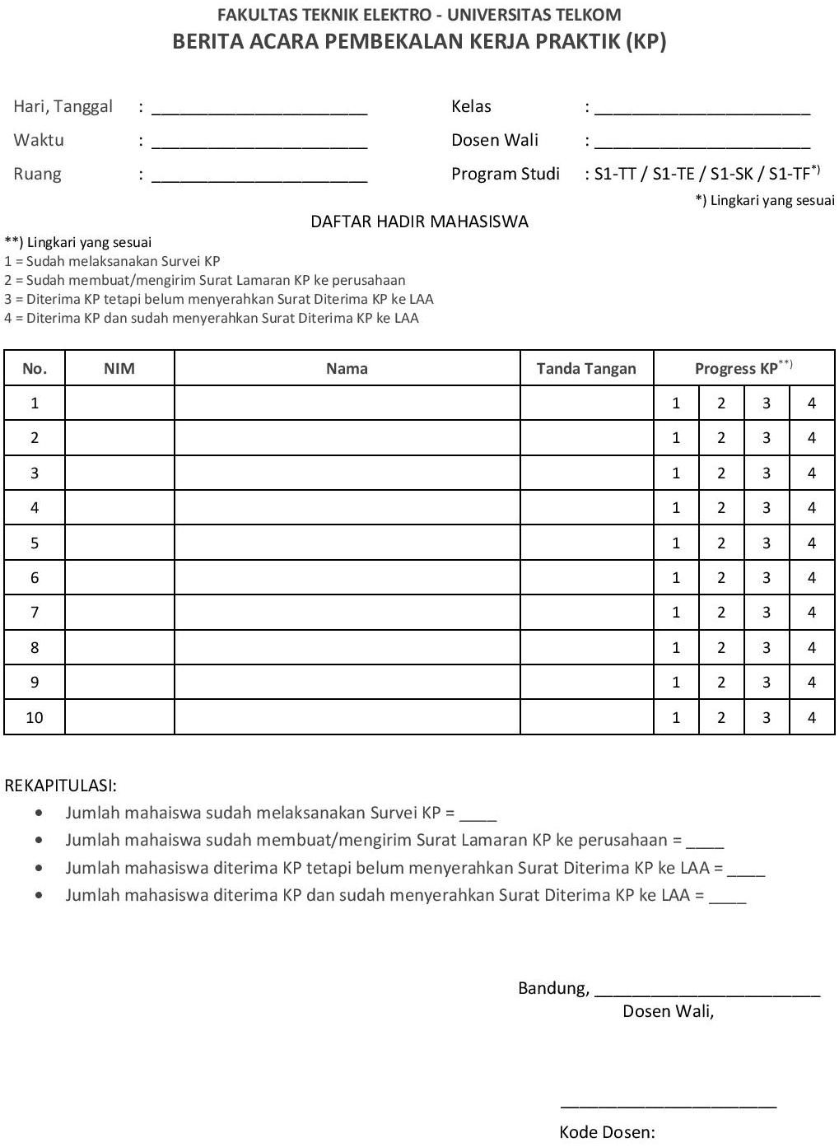

S1-TT/S1-TE/S1-TK / S1-TF*)

